IF YOU SMELL GAS-DO NOT WAIT

PEEL
&
STICK
What you smell is a harmless chemical called mercaptan.
We have added it to help you and your entire family identify natural gas.
IF YOU SMELL GAS-DO NOT WAIT
No matter how slight leave the premises and call us immediately

IF YOU SMELL GAS-DO NOT WAIT

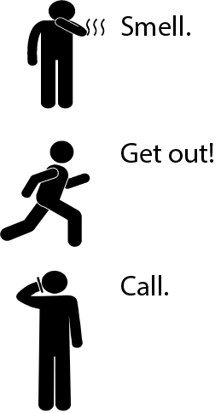
IF YOU SMELL GAS-DO NOT WAIT
Natural gas smells like rotten eggs

If you suspect a gas leak get everyone out immediately

When you are safe call New Mexico Gas Company at 1-888-664-2726

Do’s and Don’ts in a Natural Gas Emergency
- Do leave the premise immediately
- Do call New Mexico Gas Company
- Do meet our truck so you can let the representative investigate
- Do watch for signs of underground gas leaks, outdoors gas may make bubbles, blow dirt and kill plants
- Don’t remain in building to investigate
- Don’t turn on or off any appliances, lights, phones, garage door openers etc.
- Don’t smoke use lighters or matches

IF YOU SMELL GAS-DO NOT WAIT
IF YOU SMELL GAS-DO NOT WAIT
identify natural gas.
identify natural gas.

identify natural gas.

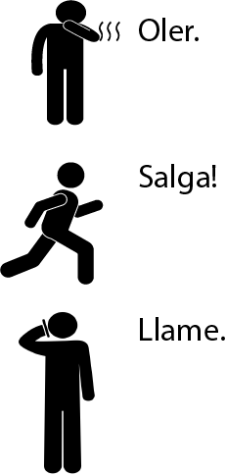
Qué hacer y que no hacer en una Emergencia de Gas Natural
- Salga del lugar inmediatamente
- Llame a New Mexico Gas Company
- Encuéntrese con nuestro vehículo para permitir que nuestro representante investigue
- Esté atento a las señales de fugas de gas subterráneas, afuera el gas puede hacer burbujas, soplar tierra y matar plantas
- NO se quede en el edificio para investigar
- NO encienda ni apague ningún aparato, luces, telefonos, abridores de puertas de garaje, etc.
- NO fume, no use encendedores o cerillos

El gas natural huele a huevos podridos

Si sospecha que hay una fuga de gas, evacue el lugar inmediatmente

Cuando estés seguro llame a New Mexico Gas Company al 1-888-664-2726

PELAR
&
PEGAR
Lo que hueles es un químico inofensivo llamado mercaptano.
Lo hemos agregado para ayudarle a usted y a toda su familia a identificar el gas natural.
SI HUELE A GAS-NO ESPERE
No importa que tan leve sea el olor salga del lugar y llámenos inmediatamente.

IF YOU SMELL GAS-DO NOT WAIT
IF YOU SMELL GAS-DO NOT WAIT

